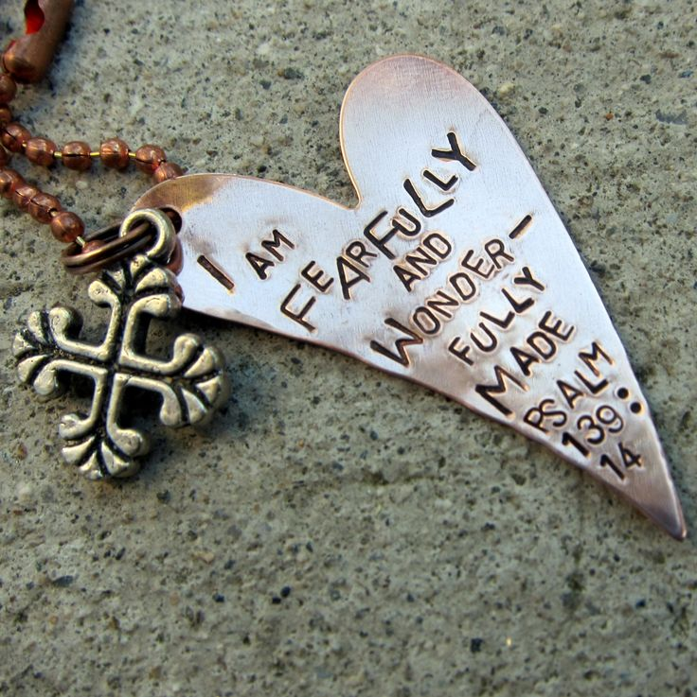
Good morning, this is Michael De Rosa, and I want to talk with you about a young man, David in light Psalms 139:14
I will give thanks to You,
for I am fearfully and wonderfully made;
Wonderful are Your works,
And my soul knows it very well.

Psalm 139:14New American Standard Bible

Here is the shortened story (the full story can be read at Joni and Friends, for which I will include a link in this transcript)

David, who was born with little chance of survival due to severe disabilities is now crossing through turbulent Mid Eastern Cultures and sharing the Gospel.

David could have easily given up, but because of caring people in his life, he surmounted the obstacles to be living a full life.

We can do the same too. If fact, we were created to celebrate the awesome creative work of God.

Now listen carefully, regardless of who you are, or what kind of baggage you have, or you limitations, God’s word still declares that you are fearfully and wonderfully made.

Too, often, though we allow hardships to come between God’s design in us and and God’s design for us.

And yet, Scripture gives us the prescription to finding our way back to standing in awe of who God created.

First, declare God’s word that from His perspective you ARE fearfully and wonderfully made

Then, allow that truth to permeate your life, the good parts, the bad parts, the painfilled parts, until to are grasped with the reality that God does not make junk, but jewels.

In closing, don’t let the world rob you of the joy of your creation.

