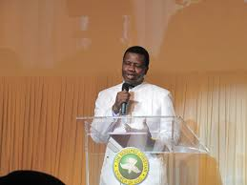
Good Morning, this is Michael De Rosa, and today I want to talk about Shepherding in light of the Gospel of John, the 21st chapter.

In the 15th verse, Jesus tells Peter to Feed my sheep.

Now lets get the big picture here, OK.

Jesus, the Lord who knows everything is exhorting –not just making a suggestion, mind you- a Sinner to take care of the sheep, namely, to take care of people like you and me.

One serious application of this s that our pastors, like Peter, are not perfect, but they are still called by God to lead us.

So, let’s not idolize them, as some do. Jesus alone is to be worshipped.

But, let’s also stop questioning their authority to lead because Jesus has called them and already knows their problems before you and I came along.

Perhaps the best way to treat our pastors is to pray for them to experience the loving forgiveness of Jesus…just like Peter did.

