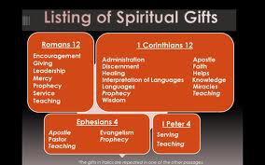
Good morning, this is Michael De Rosa, from the Mountainside Community Church here in Newport, NH, and the message today is on Spiritual Gifts.
Let me read for us 1 Timothy 4:14-16 NASB

¹⁴ Do not neglect the spiritual gift within you, which was bestowed on you through prophetic utterance with the laying on of hands by the presbytery. ¹⁵ Take pains with these things; be absorbed in them, so that your progress will be evident to all. ¹⁶ Pay close attention to yourself and to your teaching; persevere in these things, for as you do this you will ensure salvation both for yourself and for those who hear you.

God’s word exposes us to the importance of the spiritual gifts He has given us, namely that as we ‘take pains with these gifts’, or as other translations read:
‘practice’ GWT,
‘are diligent’ NIV,
‘give complete attention to’ NLT,

God will work mightily in us to save both us and others.

This is why discovering your spiritual gift, and using it is vitally important.

What can you do this day, this coming week to plan time to discover your gift?

