2013 February 10 Radio Sermonette Weather Watching

Radio Sermonette and Blog Post
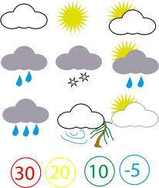
Good morning. This is Michael De Rosa and my topic today is forecasts.

In the 16th chapter of Matthew, Jesus chides the religious leaders who forecast the weather conditions, while failing to discern the signs of the times that point to our Lord’s return

And while it IS EASY to fail to heed the signs of the times BECAUSE we so quickly get caught up in our daily activities, we would do well to heed the warning that Jesus is giving here.

For instance, how often do we look at all that is happening around us through the lens of God Word in order to get God’s perspective on situations that we have pretty much now have grown to accept it by way of tolerating it

Or, think about what we are witnessing now on prime time television that would have been inappropriate some years ago. Or, not really being shocked when it is discovered that the killer of the victim was indeed the spouse. Or, hearing the confession of a public official, while he is offering excuses for his behavior.

As we learn to discern, we will better understand if our lives are on that Highway of holiness, or on trajectory towards bad times.

How good are you at forecasting

